1. Write a program to demonstrate if and while controllers in JMeter.

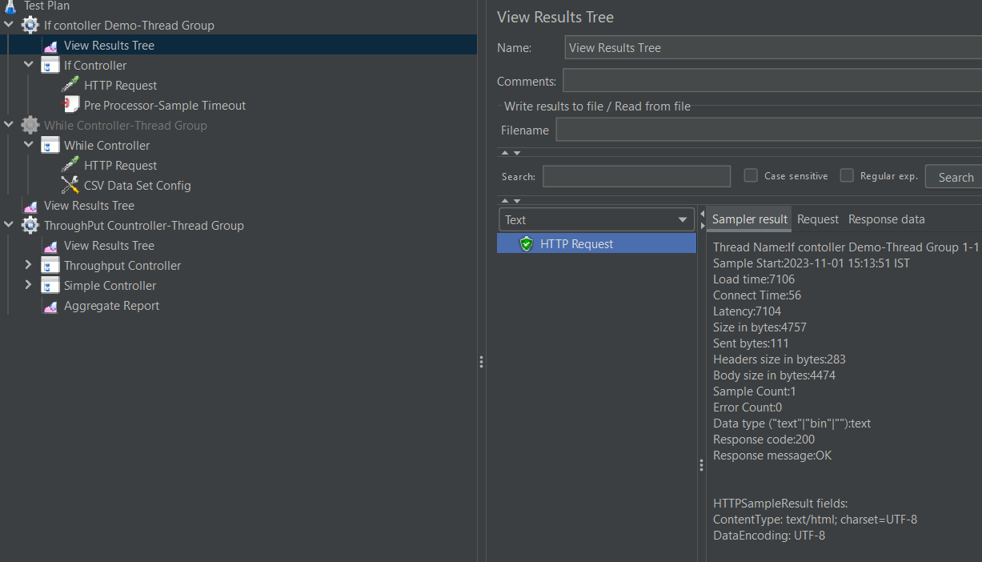

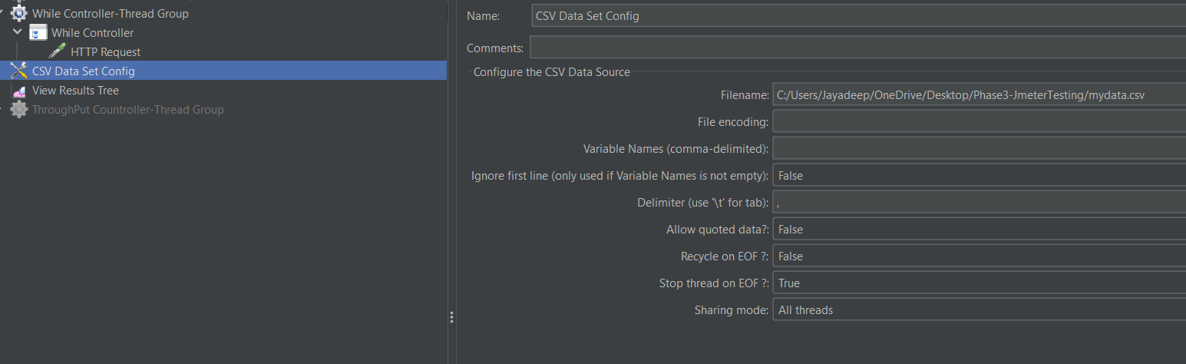

1. Write a program to demonstrate throughput controller in JMeter.

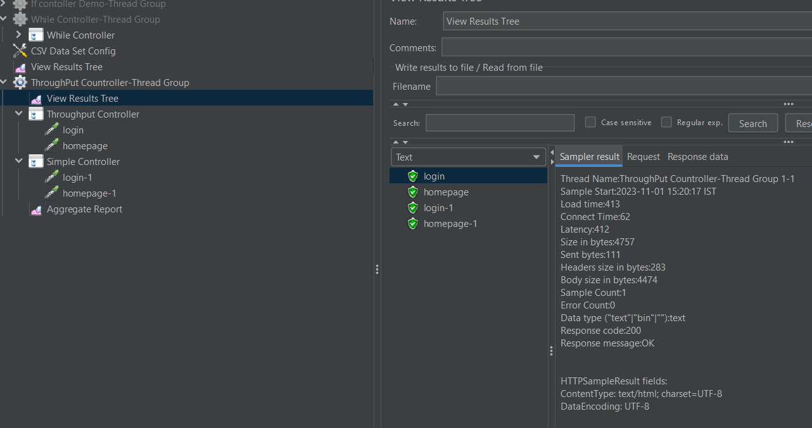

3. Write a program to demonstrate runtime controller in JMeter

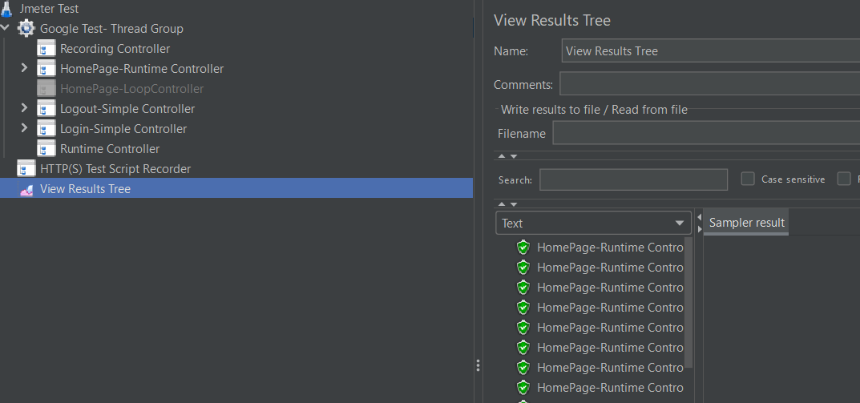

4.Write a program to demonstrate switch, module, and include controllers in JMeter

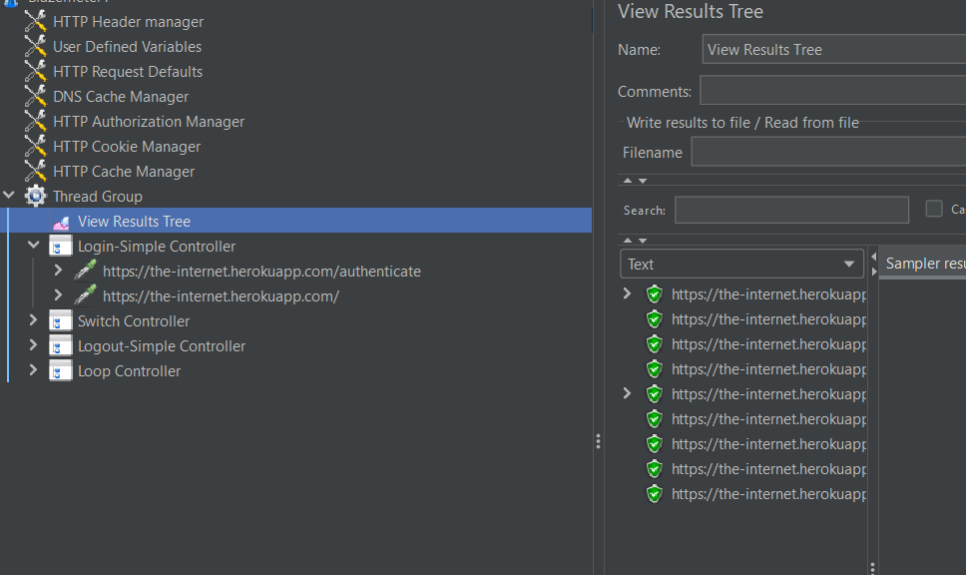

5. Write a program to demonstrate ForEach controller with regular expression extractor in JMeter.

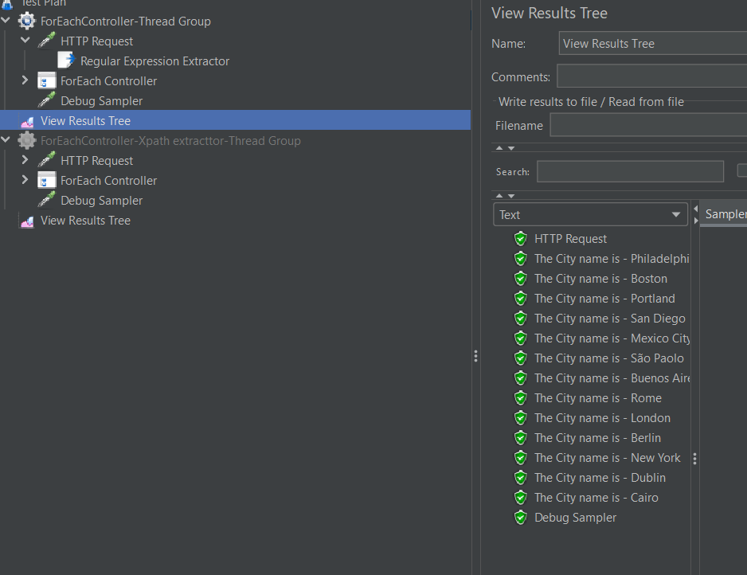

6. Write a program to demonstrate ForEach controller with Xpath extractor in JMeter.

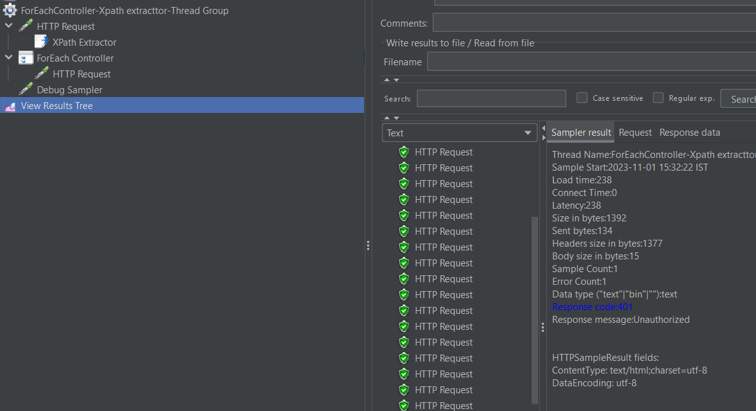

7. Write a program to demonstrate implementation of JMeter controllers using Selenium.

**Development Environment:**

* Apache JMeter 5.1.1 Version
* JDK Runtime Environment 8.1

This guide has three subsections, namely:

1.2.1 Problem statement for implementing Selenium with JMeter

1.2.2 Solution for the problem statement

1.2.3 Pushing the code to GitHub repositories

**Step 1.2.1:** Problem statement for Processors, Assertions and Timers

* Objective: Implement Selenium with JMeter for a particular domain
* Steps involved:

1. Set up JMeter.
2. Create a test plan.
3. Add thread group.
4. Record the scripts.
5. Install WebDriver plugin.
6. Write Selenium scripts in WebDriver.
7. Run the scripts and view the results.

**Step 1.2.2:** Solution for the problem statement

1. Migrating plugins manager to JMeter.

* Download WebDriver plugins for JMeter.
* Download JMeter Plugin from “<https://jmeter-plugins.org/install/Install/>”.

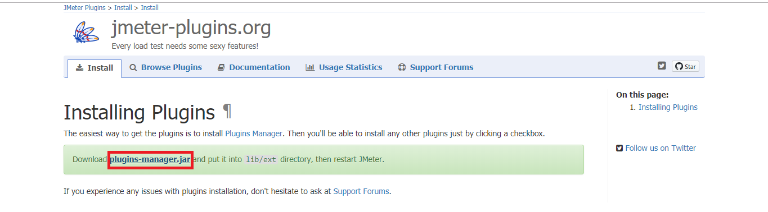

* Unzip JMeterPlugins-WebDriver 1.1.3 (version is default).
* The unzipped files must be copied to the lib folder -> ext folder of JMeter.

1. Installing WebDriver plugin

* Click on options -> click on plugins manager.

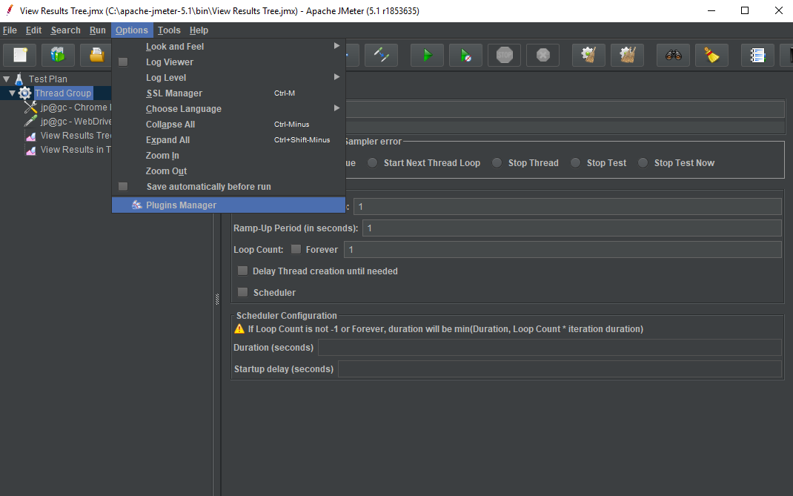

* Click on Available plugins -> click on Selenium/Web Driver Sampler.
* Click on the Restart and install button. (JMeter will automatically restart.)
* Click on install plugins -> click on Selenium/Web Driver Sampler.
* Click on the Restart and install button.(JMeter will automatically restart.)

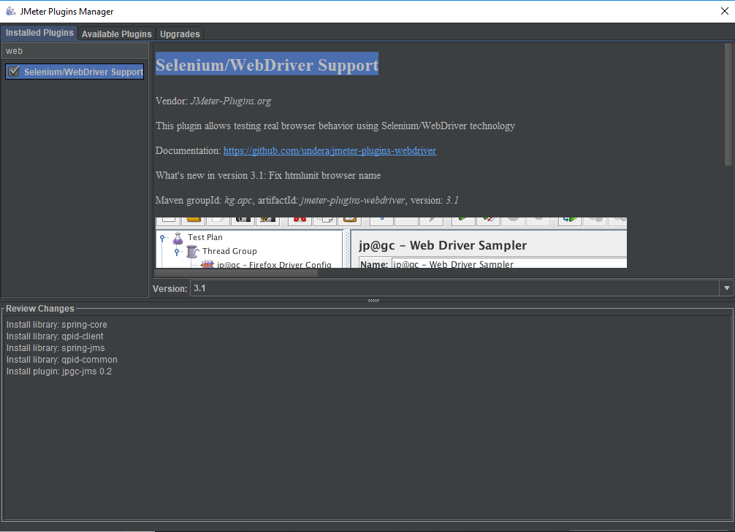

1. Writing your Selenium script.

* Right click on the Test Plan.
* Click on Add -> Thread(Users)->Thread Group.

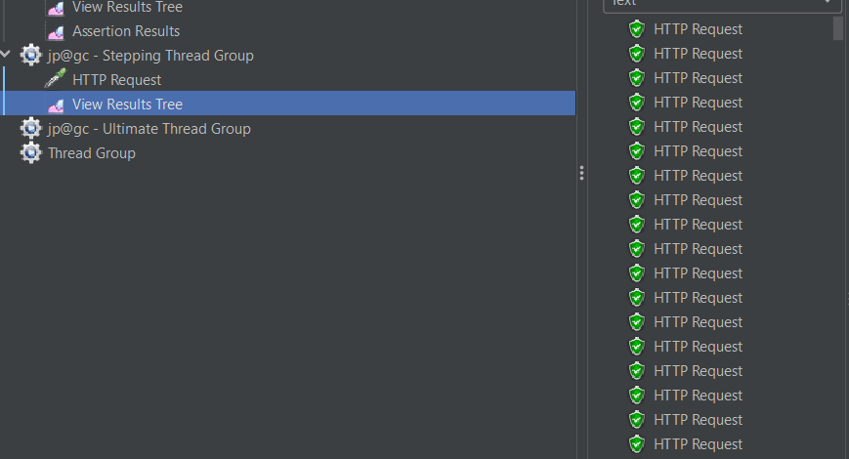

1. Write a program to demonstrate HTML assertions in JMeter

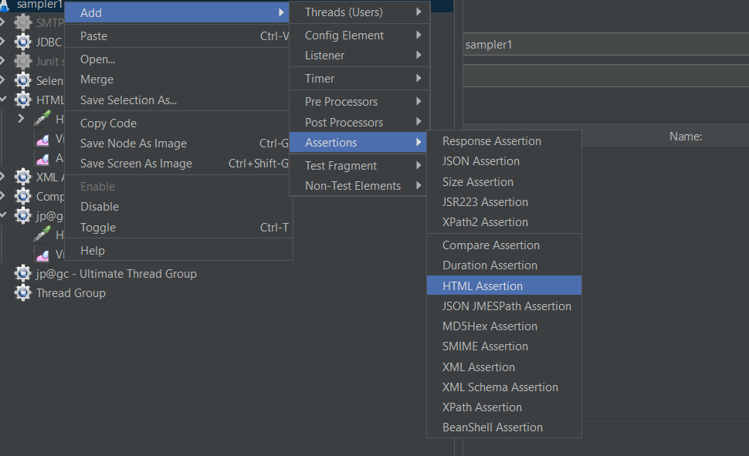

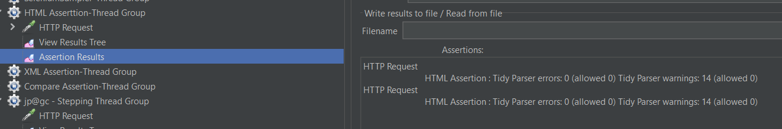

9.Write a program to demonstrate random timers (Constant, Gaussian, and Poisson timers) in JMeter

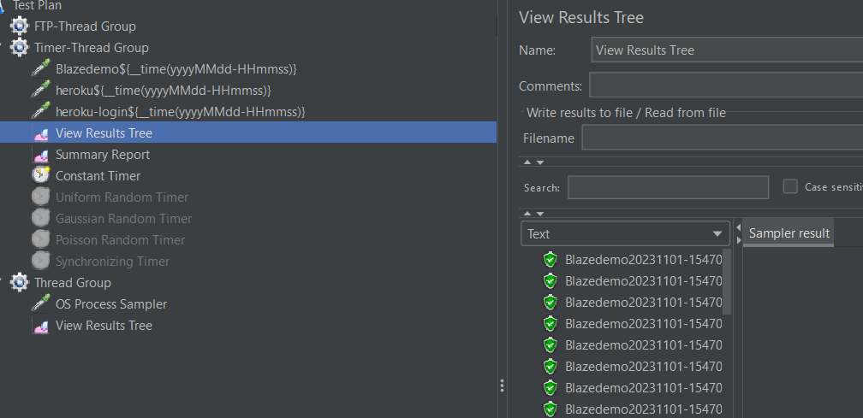

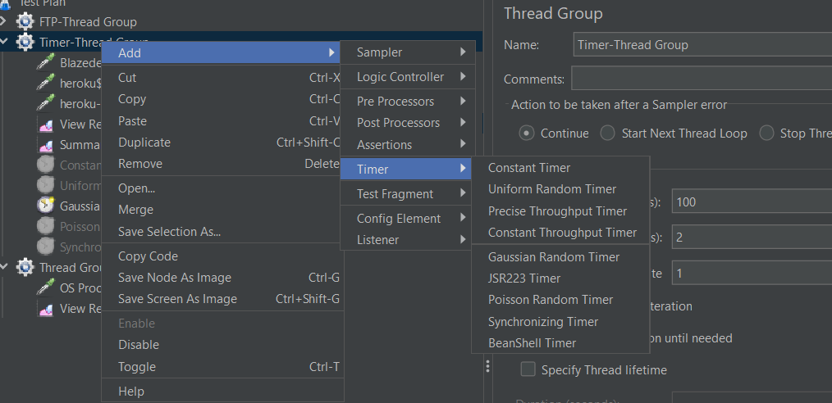

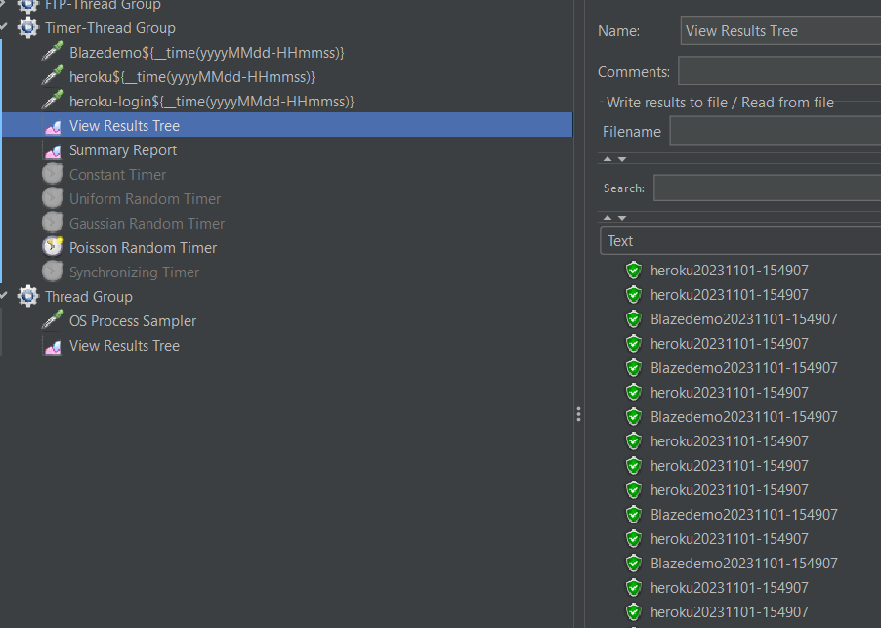

9.Write a program to demonstrate how a timer is synchronized in JMeter.

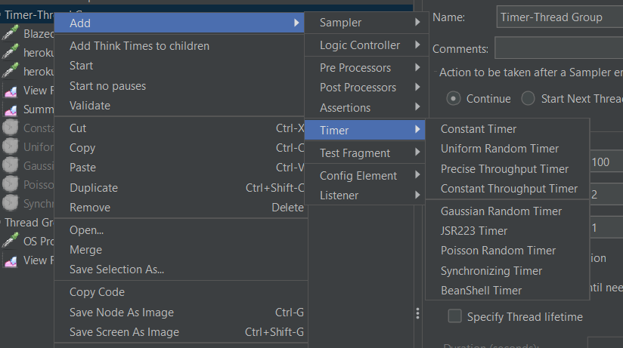

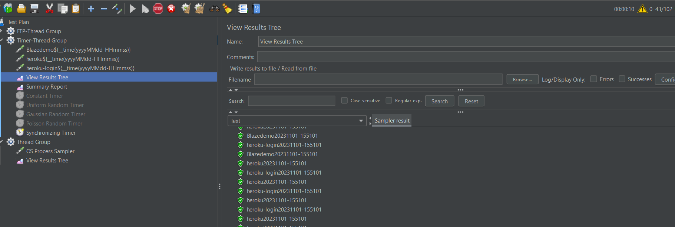

10.Write a program to demonstrate OS process, debug and test action sampler script in JMeter

